**Ideation Phase**

**Define the Problem Statements**

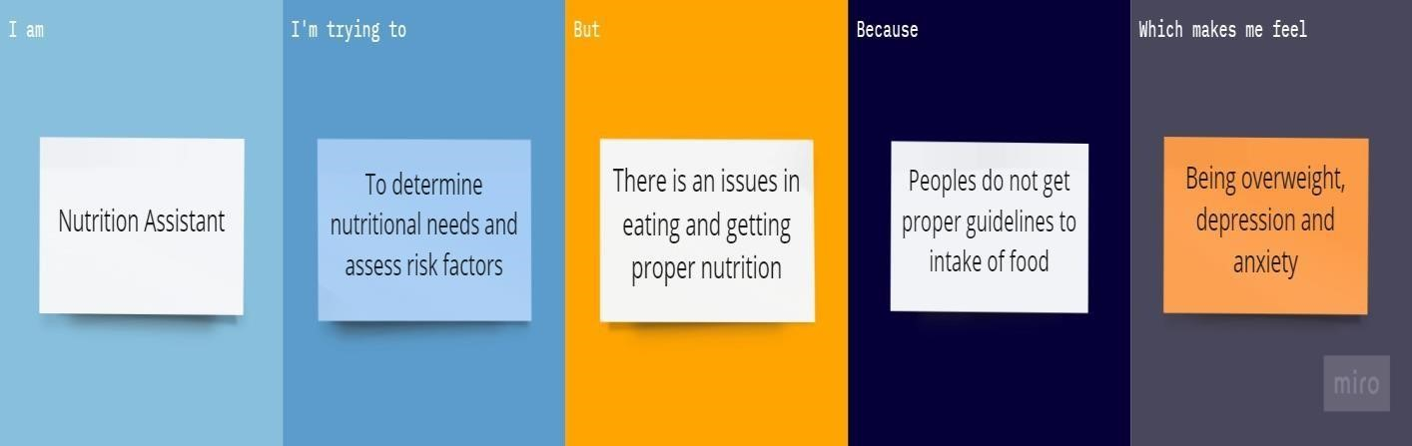

|  |  |  |  |  |  |
| --- | --- | --- | --- | --- | --- |
| Problem  Statement(PS) | I am | I’m trying to | but | Because | Which makes me  feel |
| PS-I | Nutritional assistant | To determine nutritional needs | Issues in eating proper healthy food | People do not get proper guidelines  to intake of food | Being overweight |
| PS-II | Nutritional assistant | To assess risk factor | Problem  in getting proper nutrition | People do not have proper education about nutrition’s important | Anxiety and  depression |